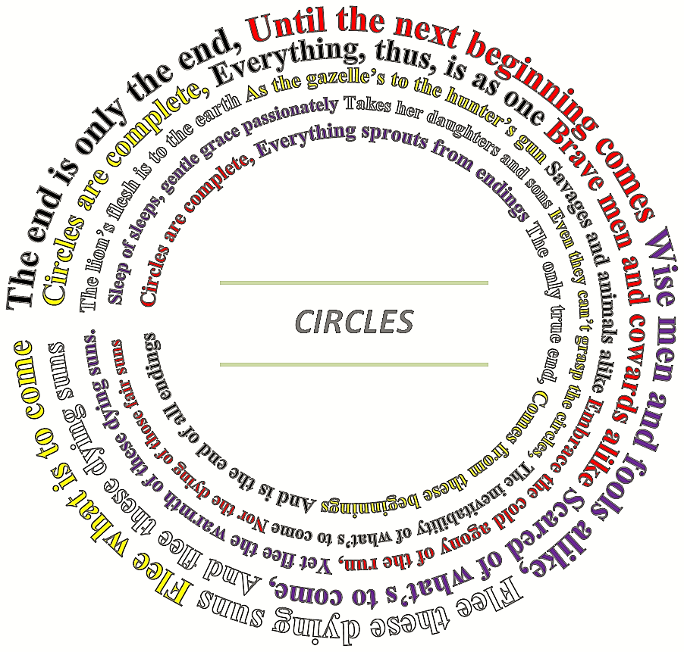
This is the correct way the Poem “Circles” should be. And if at all possible, it should stay this way. It’s in the form of a picture or image. But, if there’s some problem with formatting or something of the like, then I attached a standard version on the next page. (But it’s far, far better as an actually circle if possible)
Alexander Lousenberry

“Circles”

The end is only the end,
Until the next beginning comes
Wise men and fools alike,
Flee these dying suns
Flee what is to come

Circles are complete,
Everything, thus, is as one
Brave men and cowards alike
Scared of what’s to come,
And flee these dying suns

The lion’s flesh is to the earth
As the gazelle’s to the hunter’s gun
Savages and animals alike
Embrace the cold agony of the run,
Yet flee the warmth of these dying suns.

Sleep of sleeps, gentle grace passionately
Takes her daughters and sons
Even they can’t grasp the circles,
The inevitability of what’s to come
Nor the dying of those fair suns

Circles are complete,
Everything sprouts from endings
The only true end,
Comes from these beginnings
And is the end of all endings

